A Growing Nation
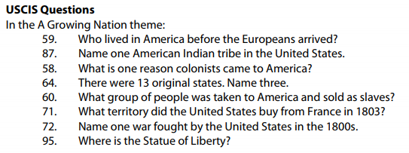
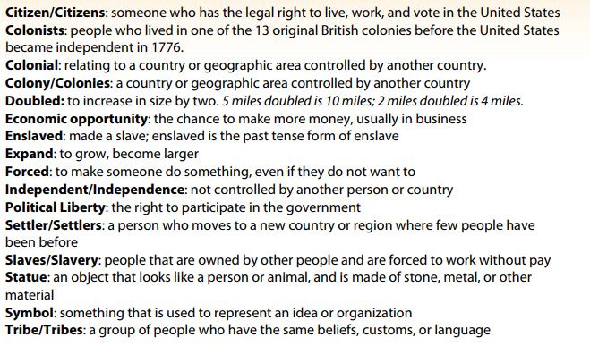
Directions: As you watch the video, write down the answers to the questions below. Eventually you’ll have your answers for all 100 civics questions.
American Indians
Who lived in America before the Europeans arrived? USCIS #59
………………………………………………………………………………………………………………………………………………………………..
American Indian Tribes
Name one American Indian Tribe in the United States. USCIS #87
………………………………………………………………………………………………………………………………………………………………..
Colonists: Purpose
What is one reason colonists came to America? USCIS # 58
………………………………………………………………………………………………………………………………………………………………..
Original States
There were 13 original states. Name three. USCIS #64
………………………………………………………………………………………………………………………………………………………………..
Slavery
What group of people was taken to America and sold as slaves? USCIS #60
………………………………………………………………………………………………………………………………………………………………..
The Louisiana Territory
What territory did the United States buy from France in 1803? USCIS #71
………………………………………………………………………………………………………………………………………………………………..
Wars in the 1800s
Name one war fought by the United States in the 1800s. USCIS #72
………………………………………………………………………………………………………………………………………………………………..
Statue of Liberty
Where is the Statue of Liberty? USCIS #95
………………………………………………………………………………………………………………………………………………………………..

